### **Working from the Home Environment & Well-Being Study Data**

Spring 2023 CS506 Data Science

Team 1

Vani Singhal([vanising@bu.edu](mailto:vanising@bu.edu))

Ming-Han Hsieh([jeff0987@bu.edu](mailto:jeff0987@bu.edu))

Wei-Tse Kao([kaowt@bu.edu](mailto:kaowt@bu.edu))

Jessica Woo ([jesswoo@bu.edu](mailto:jesswoo@bu.edu))

**Introduction**

One of the impacts of COVID-19 is the shift from in-person work to working from home. The goal of this project is to determine how transitioning to remote work has affected employees physically and mentally. The study collected data for 6 months from a group of 70 participants, all of whom were full time employees that worked remotely 90 percent of the time and used a computer for at least 4 hours a day. Each participant was given a Garmin watch which was paired with the Ecological Momentary Assessment app (meMA). The study collected physiological data from the Garmin watch such as heart rate, inter-beat interval, stress levels, calories burned, number of steps and floors climbed, and the number of minutes the participant was active for (i.e. intensityMinutes). The meMA app was used to collect data about the participant’s environment and how they behave in that environment by making them answer questions daily, weekly or monthly depending on the survey.

Our role in this project is to find how the physiological data given by the Garmin watch relates to the survey data collected from the Ecological Momentary Assessment app. We were also responsible for testing a series of hypotheses given to us by the client.

**Garmin Data Analysis**

**Cleaning the Garmin Data (by V.S)**

The Garmin data consists of data types - Heart rate, calories, steps, floors Climbed, intensity in Minutes, ibi, pulseOx, stress. In the 3 month folder there are 62 files, one for each participant. Similarly, in the 6 Month folder there are 63 files, one for each participant.

These files also have a lot of 0 values. So it is important to clean them. Firstly we comprehended the Garmin data and noticed that data types - calories, steps, floors climbed and intensity in Minutes was increasing along with the day. So for these data types we took the last value(max value). For data type - heart rate there were 0 values which is practically not possible so we replaced the 0 values with values between 60-100 (normal heart rate). Then we took the average of the values for each day. Along with this we also took the average of Stress values.

Now we have cleaned the data. The last step was to combine each file to one csv file.

The cleaned data can be found [here](https://drive.google.com/drive/folders/1gHvvxFBsXZCGluVb0R--hfh2K6jsPTsB?usp=share_link).

**Exploratory Analysis of the Garmin Data and Survey Data**

With the preprocessed Garmin data, we compared it to each of the survey data given by the Ecological Momentary Assessment app. For all of our analyses, we plotted the Garmin data type and a variable of a specific survey onto a dual y-axis graph to visualize the relationship between the two variables. We then calculated the Pearson correlation coefficient for each relationship and performed hypothesis testing to determine if the value was statistically significant or not. For the hypothesis test, this was our null and alternative hypotheses:

* *H0 =* correlation coefficient is not statistically significant
* *HA =* correlation coefficient is statistically significant

We used the conventional α = 0.05 for our hypothesis testing.

**Potential Relationships between Garmin data and the Flourishing Scale (by Han and V.S)**

The Flourishing Scale is a survey that measures the mental well-being of participants. It has the following six domains:

* Happiness and Life Satisfaction.
* Mental and Physical Health
* Meaning and Purpose
* Character and Virtue
* Close Social Relationships
* Financial and Material Stability

There were two questions for each domain, and for each question participants gave a score from 1 to 10 (0 = “Poor”, 10 = “Excellent”).

To begin our analysis, we first calculated the score for each domain in the Flourishing Scale, then took the sum of all scores from each domain and labeled it as “Secure Flourish”. Next, we merged this data with our preprocessed Garmin data and filtered out any data that were not from May to October. Then we grouped this filtered data by month and calculated the mean for each Garmin data type and each Flourishing Scale domain. This allowed us to observe changes in the data from the first month to the sixth month.We tested all of the relationships between each Garmin data type and each domain in the Flourishing Scale survey.

**Figure 1**

*Heart Rate vs. Mental and Physical Health*

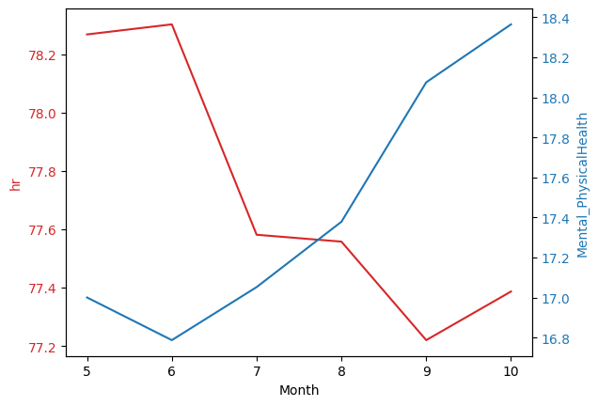

*Note.* There is a negative correlation with coefficient *r* = -0.811 and *P*–value = 0.050.

**Figure 2**

*Calories vs. Happiness and Life Satisfaction*

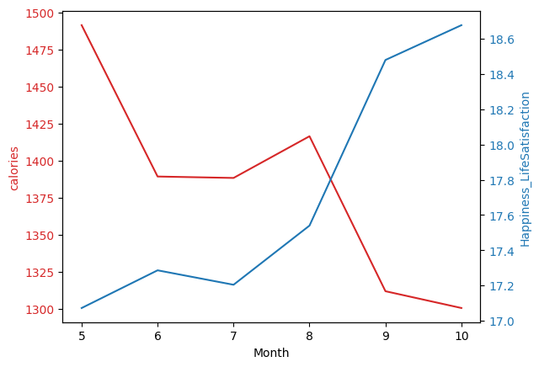

*Note*. There is a negative correlation with coefficient *r* = -0.880 and *P*–value = 0.021.

**Figure 3**

*Heart Rate vs. Character and Virtue*

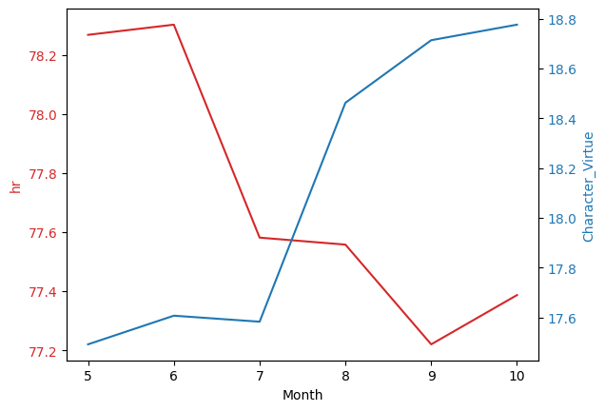

*Note.* There is a negative correlation with coefficient *r* = -0.820 and *P*-value = 0.046.

**Figure 4**

*Calories vs. Close Social Relationship*

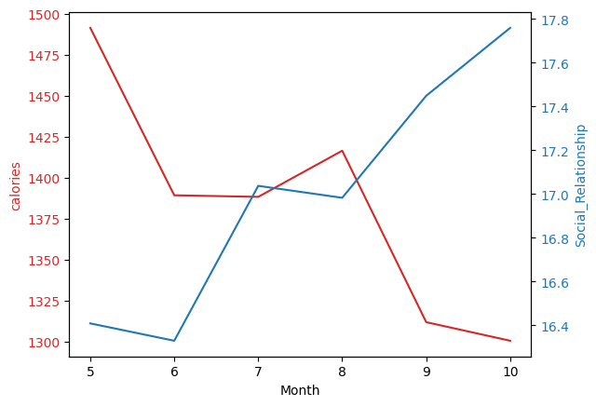

*Note.* There is a negative correlation with coefficient *r =*  -0.825 and *P-*value = 0.043.

**Figure 5**

*Stress vs. Close Social Relationship*

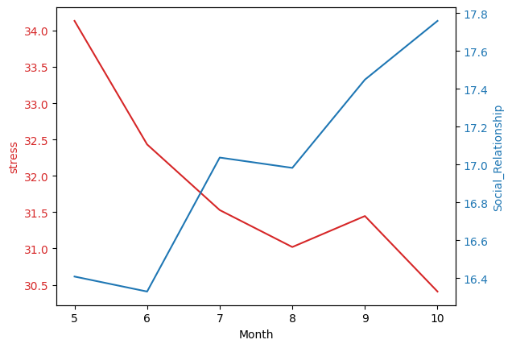

*Note.* There is a negative correlation with coefficient *r =* -0.819 and *P-*value = 0.046.

**Figure 6**

*Heart Rate vs. Close Social Relationship*

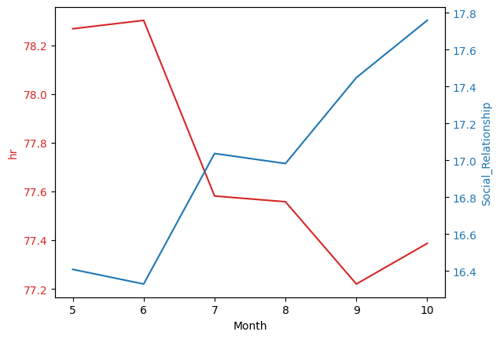

*Note.* There is a negative correlation with coefficient *r =* -0.929 and *P-*value = 0.007.

**Table 1**

*Summary of Relationships for each Garmin Data Type vs. Mental and Physical Health*

| Garmin data type vs. Mental and Physical Health | Pearson correlation coefficient (*n* = 42) | *P*-value | Is it statistically significant? |
| --- | --- | --- | --- |
| Floors Climbed | 0.295 | 0.570 | No |
| Intensity Minutes | -0.211 | 0.688 | No |
| Calories | -0.790 | 0.062 | No |
| Heart Rate | -0.811 | 0.05 | Yes |
| Steps | 0.071 | 0.894 | No |
| Stress | -0.670 | 0.145 | No |

**Table 2**

*Summary of Relationships for each Garmin Data Type vs. Happiness and Life Satisfaction*

| Garmin data type vs. *Happiness and Life Satisfaction* | Pearson correlation coefficient (*n* = 42) | *P*-value | Is it statistically significant? |
| --- | --- | --- | --- |
| Floors Climbed | 0.157 | 0.767 | No |
| Intensity Minutes | -0.305 | 0.557 | No |
| Calories | -0.880 | 0.021 | Yes |
| Heart rate | -0.761 | 0.079 | No |
| Steps | -0.100 | 0.851 | No |
| Stress | -0.684 | 0.134 | No |

**Table 3**

*Summary of Relationships for each Garmin Data Type vs. Meaning and Purpose*

| Garmin data type vs. *Meaning and Purpose* | Pearson correlation coefficient (*n* = 42) | *P*-value | Is it statistically significant? |
| --- | --- | --- | --- |
| Floors Climbed | 0.116 | 0.827 | No |
| Intensity Minutes | 0.124 | 0.815 | No |
| Calories | -0.563 | 0.245 | No |
| Heart Rate | -0.515 | 0.295 | No |
| Steps | 0.189 | 0.720 | No |
| Stress | -0.333 | 0.519 | No |

**Table 4**

*Summary of Relationships for each Garmin Data Type vs. Character and Virtue*

| Garmin data type vs. *Character and Virtue* | Pearson correlation coefficient (*n* = 42) | *P*-value | Is it statistically significant? |
| --- | --- | --- | --- |
| Floors Climbed | 0.448 | 0.373 | No |
| Intensity Minutes | -0.085 | 0.873 | No |
| Calories | -0.744 | 0.090 | No |
| Heart Rate | -0.820 | 0.046 | Yes |
| Steps | 0.217 | 0.680 | No |
| Stress | -0.762 | 0.078 | Yes |

**Table 5**

*Summary of Relationships for each Garmin Data Type vs. Close Social Relationship*

| Garmin data type vs. *Close Social Relationship* | Pearson correlation coefficient (*n* = 42) | *P*-value | Is it statistically significant? |
| --- | --- | --- | --- |
| Floors Climbed | 0.412 | 0.417 | No |
| Intensity Minutes | -0.434 | 0.390 | No |
| Calories | -0.825 | 0.043 | Yes |
| Heart Rate | -0.929 | 0.007 | Yes |
| Steps | -0.006 | 0.991 | No |
| Stress | -0.819 | 0.046 | Yes |

**Table 6**

*Summary of Relationships for each Garmin Data Type vs. Financial and Material Stability*

| Garmin data type vs. *Financial and Material Stability* | Pearson correlation coefficient (*n* = 42) | *P*-value | Is it statistically significant? |
| --- | --- | --- | --- |
| Floors Climbed | 0.321 | 0.535 | No |
| Intensity Minutes | -0.069 | 0.897 | No |
| Calories | -0.760 | 0.079 | No |
| Heart Rate | -0.734 | 0.097 | No |
| Steps | 0.141 | 0.789 | No |
| Stress | -0.692 | 0.128 | No |

**Table 7**

*Summary of Relationships for each Garmin Data Type vs. Secure Flourish Score*

| Garmin data type vs. *Secure Flourish Score* | Pearson correlation coefficient (*n* = 42) | *P*-value | Is it statistically significant? |
| --- | --- | --- | --- |
| Floors Climbed | 0.330 | 0.523 | No |
| Intensity Minutes | -0.157 | 0.766 | No |
| Calories | -0.797 | 0.058 | No |
| Heart Rate | -0.804 | 0.054 | No |
| Steps | 0.109 | 0.837 | No |
| Stress | -0.710 | 0.114 | No |

The result shows that the heart rate and calories burned may have lots of negative effects on the flourishing scale. The heart rate would lead to a lower value of physical and mental health, Character and Virtue and Social Relationships (Figure 1, Figure 3, and Figure 6). In addition, the calories burned would affect the value of Happiness and Life Satisfaction and Social Relationships(Figure 2 and Figure 4).

It is also interesting to see that though “Secure Flourish Score” (sum of all domains) does not have any relationship with the Garmin data type, yet some of individual domains like Close Social Relationship, Mental and Physical Health have relationship with Garmin data types.

***Additional Analysis of the Flourishing Scale Survey***

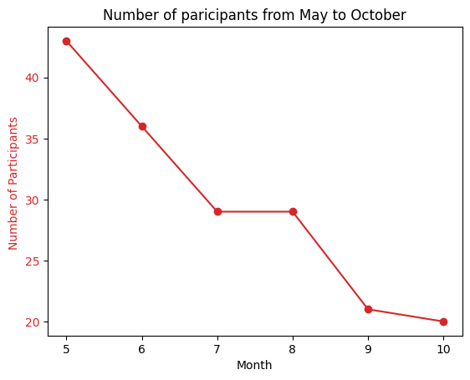

The above graph shows only participants who participated and filled the Flourishing Scale survey over a period 6 months. It is interesting to find that the number of participants kept on decreasing from May to October. This shows that participants found it difficult to keep up with the demands of the study, which is expected since the Flourishing Scale had to be answered everyday.

**Potential Relationships between Garmin data and the Joint Pain Homunculus (by J.W.)**

For both the 3-month Garmin data and the 6-month Garmin data, I compared it to the Joint Pain Homunculus data that was collected from participants once per day. The survey asked participants to indicate whether or not they felt pain at the specified body part based on the Visual Analog Scale (0 meaning “no pain”). Because the Homunculus data was split into *Daily PM* and *Friday PM*, I combined (i.e. concatenated) the two datasets. I then calculated a score for the Homunculus, which is the sum of all of the values for each body part. A lower score would mean the participant did not experience much pain for that day, whereas a higher score would indicate that they felt more pain. There were a total of 68 body parts in the homunculus. Then, I merged the homunculus data with the Garmin data, and then found the mean for each month. I graphed each Garmin data type and the homunculus data on a dual axis graph and calculated the Pearson correlation coefficient to determine the relationship between the two variables. The only statistically significant relationship that I found was with stress, which is shown in Figure 7.

**Figure 7**

*Stress vs. Total Scores of the Joint Pain Homunculus*

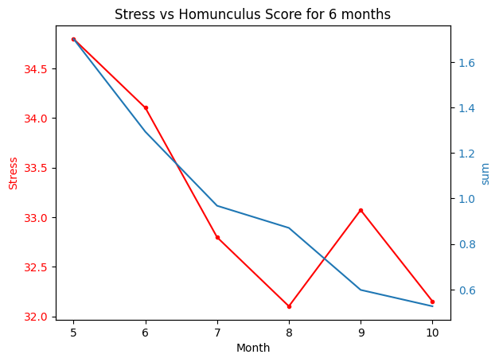

*Note*. There is a positive correlation with coefficient *r* = 0.871 and *P-*value = 0.024.

The positive correlation between stress and the total homunculus score is expected since it’s a biological response for humans to have higher levels of stress when they are experiencing pain. Comparing this to the results found in Table 1, which show that there is no significant relationship between stress and the participant’s mental and physical health, it seems that stress is more strongly related to a participant’s physical health and that mental well-being has no apparent effect on stress.

**Table 7**

*Summary of Relationships for each Garmin Data Type vs. Homunculus*

| Garmin data type vs. Homunculus score | Pearson correlation coefficient (*n* = 41) | *P*-value | Is it statistically significant? |
| --- | --- | --- | --- |
| Floors Climbed | 0.776 | 0.069 | No |
| Intensity Minutes | -0.122 | 0.818 | No |
| Calories | 0.696 | 0.125 | No |
| Steps | 0.537 | 0.272 | No |
| Heart rate | -0.615 | 0.193 | No |
| Stress | 0.871 | 0.024 | Yes |

***Additional Analysis of the Joint Pain Homunculus***

I also looked for possible trends within the homunculus data over the course of the study and found that there was a definite decrease in the number of participants that experienced pain from the first month of working from home to the sixth month as shown in Figure 8.

**Figure 8**

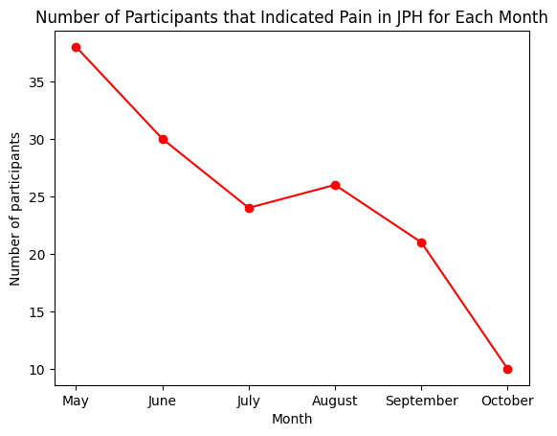

*Note*. Only participants that were in the study for the entire six months were considered.

I then looked for which body parts the participants experienced pain in and found the top three most common places of pain for each month, which is shown in Table 8. For the first five months of the study, the most common place of pain is the lower back. However, for the sixth month the most common place of pain is the right-collarbone. This suggests that while lower-back pain can go away with time, right-collarbone pain does not and needs to be actively managed. One possible reason that participants seem to be experiencing pain in these areas could be due to workstation ergonomics, which ultimately affects posture. However, further exploration would be needed in order to confirm this, which we could do by analyzing the Computer Workstation Checklist to see if participants who have similar answers also have similar scores in the homunculus.

Although the Joint Pain Homunculus does not indicate whether or not the pain was a pre-existing condition of the participant, the fact that the number of participants is decreasing as the study progresses seems to prove that the pain is related to how long the person has been working remotely.

**Table 8**

*Top Three Most Common Places of Pain for Each Month*

| Month | Body Part in Pain | Number of Participants |
| --- | --- | --- |
| May | 1. Lower back | 13 |
| 1. Right-collarbone, neck | 10 |
| 1. Left-collarbone | 9 |
| June | 1. Lower back | 8 |
| 1. Mid-back, upper-back | 6 |
| 1. Right-collarbone, neck | 5 |
| July | 1. Lower back | 9 |
| 1. Right-collarbone | 6 |
| 1. Right-hip | 5 |
| August | 1. Lower back | 9 |
| 1. Neck | 6 |
| 1. Upper-back, right-collarbone, right-hip | 5 |
| September | 1. Lower back | 6 |
| 1. Left-knee, right-collarbone | 4 |
| 1. Right-knee, left-shoulder, right-hip, left-hip | 3 |
| October | 1. Left-knee, right-collarbone, neck | 3 |
| 1. Right-knee, left-collarbone | 2 |

*Note*. There are only two rows for October because the remaining body parts only have 1 participant.

**Potential Relationships between Garmin data and E-Work Life Scale (by Wei-Tse)**

The E-Worklife Scale survey is an assessment of how participants feel about their work based on the following four domains:

* Organizational Trust
* Flexibility
* Work-life Interference
* Effectiveness/Productive

There are four to six questions for each domain, and for each question, participants gave a score from 1 (strongly agree) to 5 (strongly disagree).

The following are the steps I took to preprocess the E-Work Life Scale data and the Garmin data:

1. The E-work Life scale data was in Friday_PM survey data.
2. Merged the cleaned garmin data and this survey data. We filtered out the 6 month data from May to October.
3. Grouped the merged data by month and calculated the mean for each Garmin data type and domains.
4. Calculated the total score for each domain.
5. Calculated the “E_Worklife_Scale” which is the summation scores of each domain from all four domains.

**Figure 9**

*Organizational Trust vs. Calories*

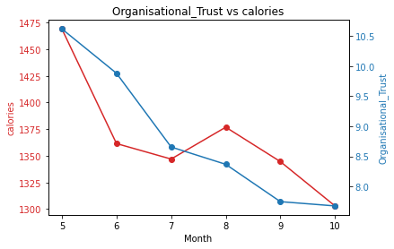

*Note.* There is a positive correlation with coefficient *r =* 0.827 and *P*-value = 0.042

**Figure 10**

*Organizational Trust vs. Heart Rate*

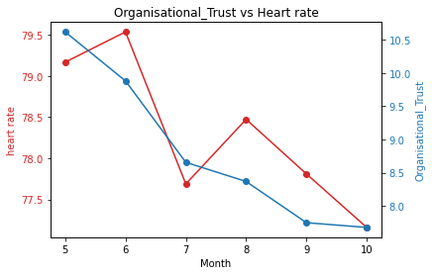

*Note*. There is a positive correlation with coefficient *r* = 0.866 and *P*-value = 0.026

**Figure 11**

*Work-life Interference vs. Calories*

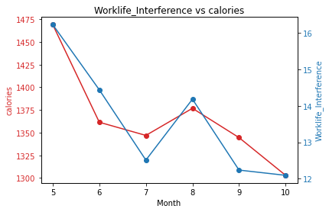

*Note.* There is a positive correlation with coefficient *r =* 0.921 and *P-*value = 0.009.

**Figure 12**

*Work-Life Interference vs. Heart Rate*

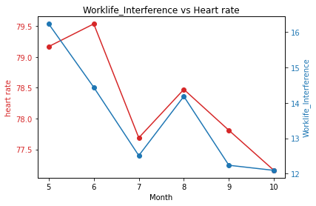

*Note*. There is a positive correlation with coefficient *r =* 0.864 and *P-*value = 0.026.

**Figure 13**

*Effectiveness/Productive vs. Heart Rate*

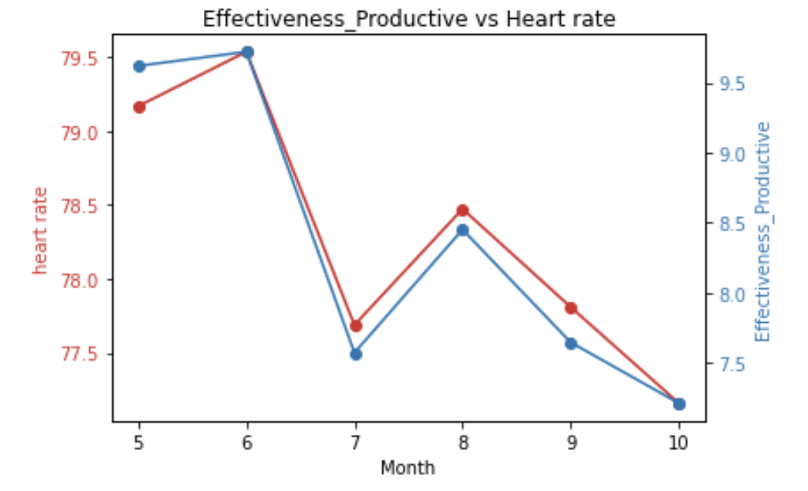

*Note.* There is a positive correlation with coefficient *r* = 0.988 and *P-*value = 0.000

**Figure 14**

*E-Work Life Scale Total Score vs. Calories*

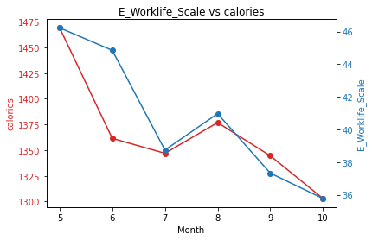

*Note*. There is a positive correlation with coefficient *r =* 0.836 and *P*-value = 0.038.

**Figure 15**

*E-Work Life Scale Total Score vs. Heart Rate*

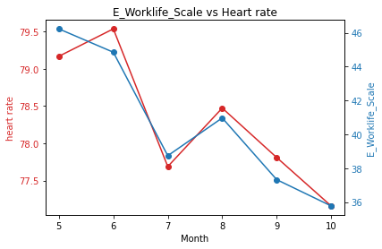

*Note*. There is a positive correlation with coefficient *r =* 0.960 and *P-*value = 0.002

**Table 9**

*Summary of All Relationships between Garmin Data and E-Work Life Scale  
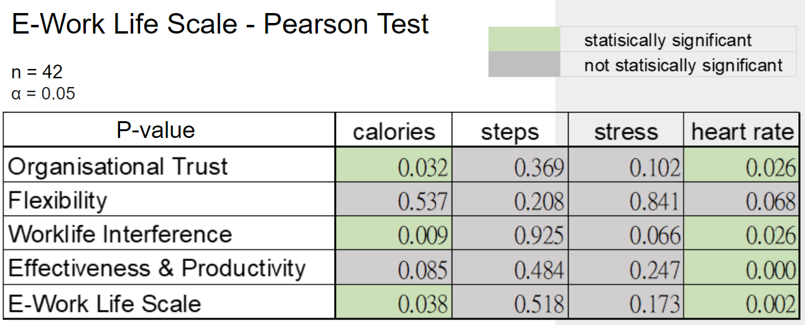*

As I mentioned above, the lower score of the E-work Life Scale means a worker leads a more comfortable life while working from home. We can observe that the calories the worker burned and the average heart rate of the worker exist in a positive and significant statistical relationship, and that is to say, the workers with lower calories burned and lower average heart rate would probably lead a more comfortable working lifestyle while working from home.  
**Potential Relationships between Garmin data and the Computer Workstation Checklist (byV.S)**

Computer Workstation is a set of questions based on the workstation a participant uses to work. Participants complete this survey monthly. It has 15 questions and participants have to give answers in either ‘yes’ or ‘no’.

For the analysis we first calculate the sum to get a total score for all questions where yes indicates 1 and no indicates 0 values.

**Table 10**

*Summary of Relationships for each Garmin Data Type vs. Score of Computer Workstation Checklist*

| Garmin data type vs. Total Score | Pearson correlation coefficient (*n* = 37) | *P*-value | Is it statistically significant? |
| --- | --- | --- | --- |
| Floors Climbed | -0.086 | 0.871 | No |
| Intensity Minutes | -0.335 | 0.517 | No |
| Calories | -0.237 | 0.651 | No |
| Steps | 0.509 | 0.302 | No |
| Heart rate | -0.756 | 0.082 | No |
| Stress | -0.750 | 0.086 | No |

The above results show that there is no significant relationship between Garmin data and Computer Workstation Checklist

**Relationship between Garmin data and Age (by Han):**

Using the demographic data given to us, I found that participants’ age ranged from 22 to 65. I grouped the participants by age and then calculated the mean values of the Garmin data values.

**Figure 16**

*IntensityMinutes vs. Stress*

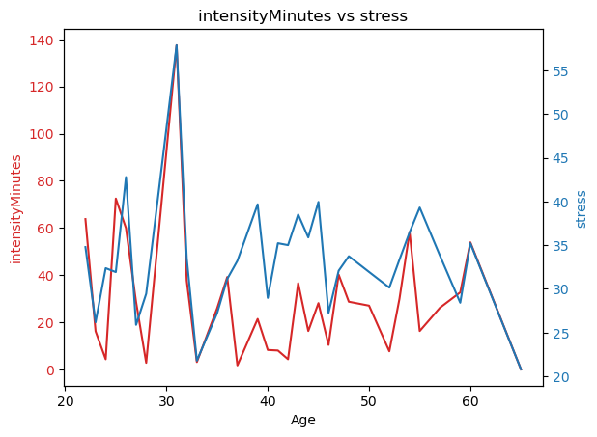

*Note.* There is a positive correlation with coefficient *r* = 0.686 and *P-*value = 0.001

Figure 16 shows that the intensityMinutes have a positive correlation with stress in the age domain. Since all of the previous work is analyzing the data on the time domain (Month), we want to find out if we can find more relationships on the age domain.

**Hypothesis Testing**

**Hypothesis A** (by Vani)

Participants’ age will negatively correlate with financial and material stability (the last two questions on the Flourishing Scale)

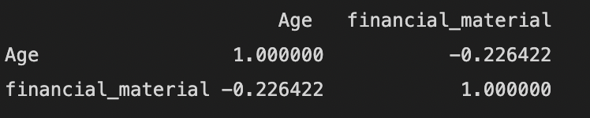

*Note.* 3 month data (correlation used here is pearson correlation)

It can be seen that there is negative correlation between participants’ age and financial and material stability with a correlation value of -0.22.

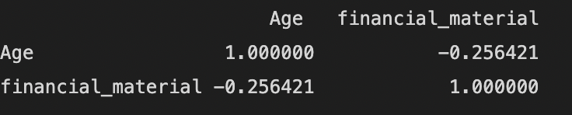

*Note.* 6 month data

It can be seen that there is negative correlation between participants' age and financial and material stability with correlation value of -0.25.

This hypothesis is correct for 3 months as well as 6 months data

**Hypothesis B (by Jessica)**

Participants who take an average of 4 breaks per day will positively correlate with productivity scores in the E-Work Life Scale (questions 16-20) and report lower discomfort at one month compared to six-month data.

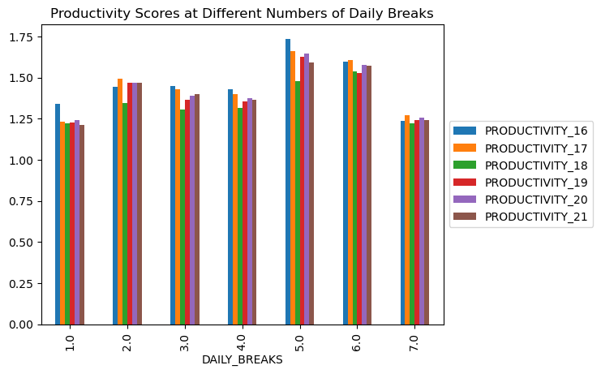

There is a positive correlation between taking an average of 4 daily breaks and productivity scores. The bar graph shows when participants take 4 daily breaks, the average productivity scores are between 1.0 and 1.5, which means that most participants reported better productivity (lower scores mean better productivity, higher scores mean worse productivity).

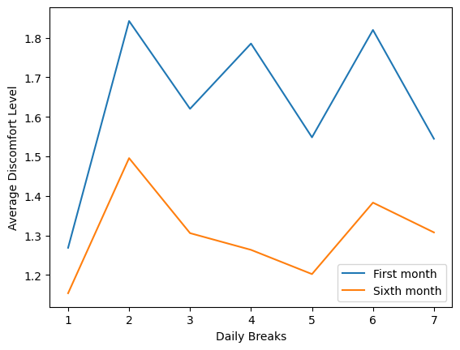

Participants who take 4 daily breaks experienced a higher discomfort during the first month, but had a lower discomfort level during the sixth month. The graph also shows that there was an overall decrease in discomfort from the first month of working from home to the sixth month, which suggests that the participants got used to working remotely. Participants who took 2 daily breaks and 6 daily breaks experienced the most discomfort for each month.

**Hypothesis C (by Han)**

Participants working in healthcare will have lower mental health scores on the Flourishing Scale than those working in other industries.

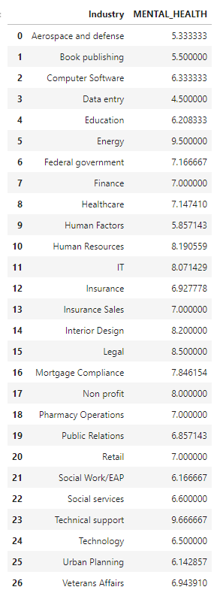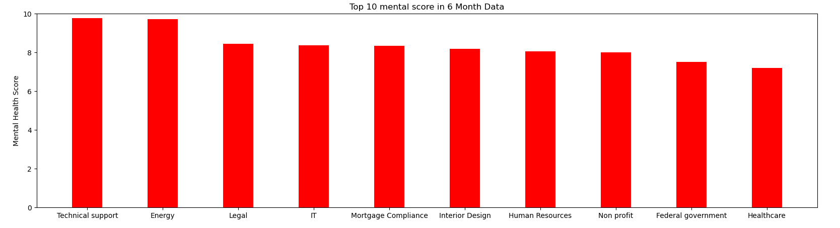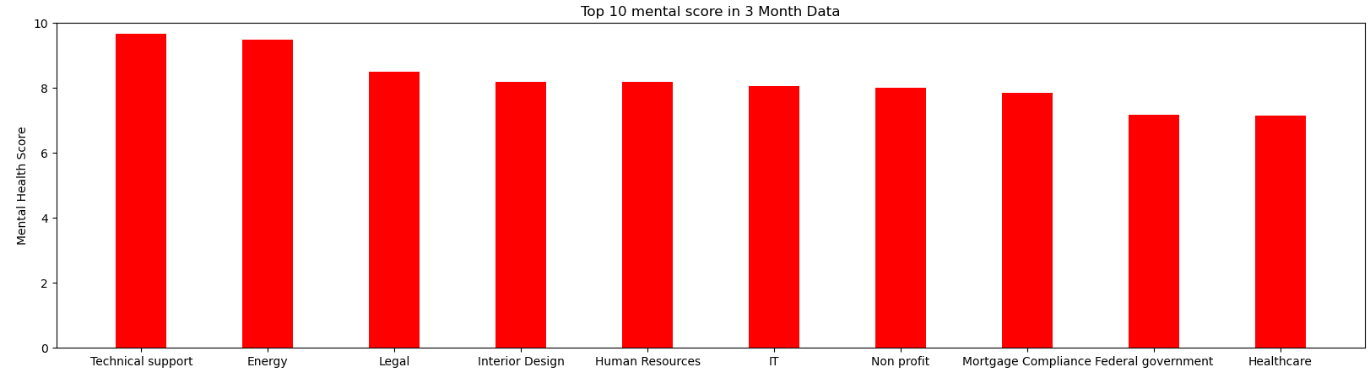

Totally, there are 26 unique industries in our dataset. We plot the top 10 industries that have the highest mental score. However, in both 6 month and 3 month data, we can observe that Healthcare has the 10th highest mental score in 26 industries. Therefore, we can confirm that the hypothesis is not valid. So maybe we take a look at what kind of jobs would really have the lowest mental score:

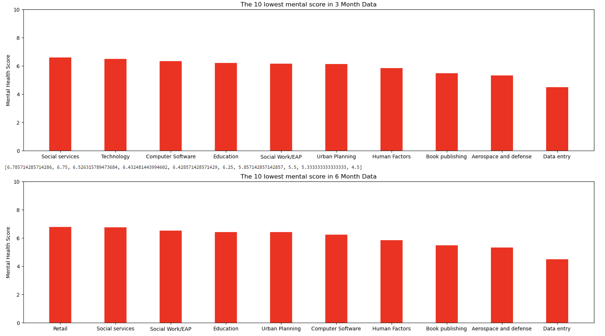

Here are the industries that have the lowest mental score. We can observe that the lowest mental score industry is Data Entry in both 3 month data and 6 month data.

**Hypothesis D (by Han and Wei-Tse)**

Participants' stress algorithm will be inversely correlated to their number of breaks.

***Preprocessing***

We dropped all the 0 stress value since we can’t confirm that the value is actually 0 or is missing. 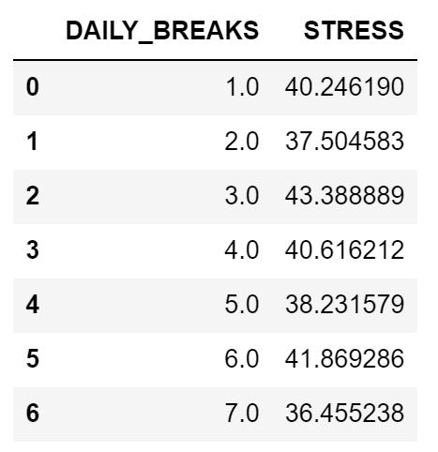

Then we plot the linear regression line when daily breaks in the x axis and stress in y axis.

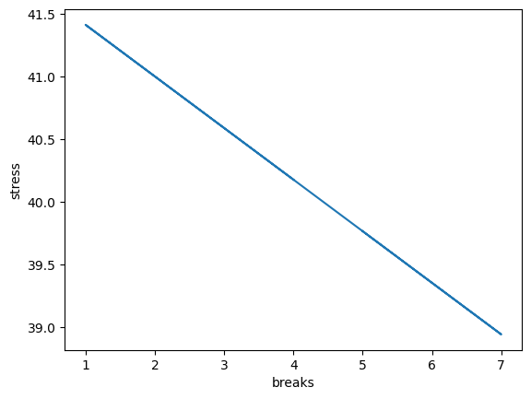

We can clearly see the inverse relationship between daily breaks and stress value. However, if we take a deeper look at the data, we would find out that the data is pretty distributed. That is, the correlation is not as strong as we thought.

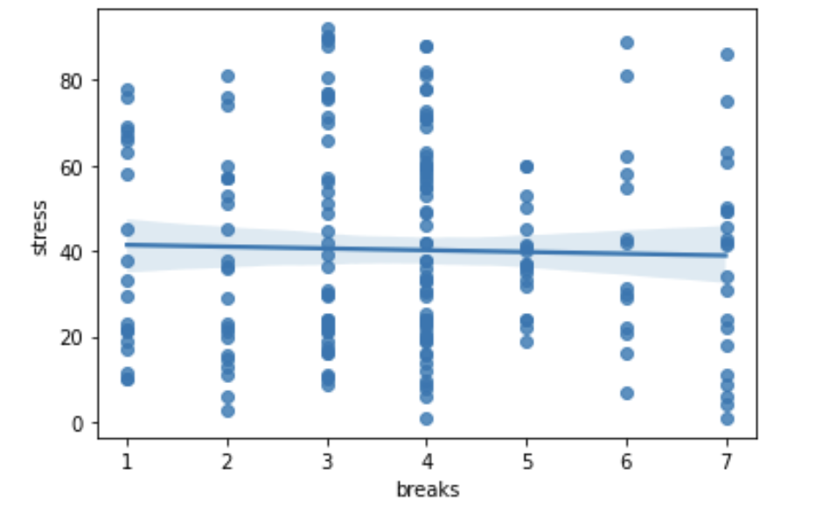

***The conclusion***

The correlation between participants’ stress levels and the number of breaks is slightly inverse.

**Hypothesis e (by J.W and V.S)**

Based on question #15 in the Computer Workstation Checklist (with 4 responses regarding ergonomics training), participants with lower scores will report less pain at 6-months.

***Pre-processing steps***

1. Extracted the six month data from *Daily PM, Friday AM,* and *Computer Workstation Checklist*
2. Extracted the columns that represent question 15 in *Computer Workstation Checklist*
3. For *Daily PM*:
   1. Categorized the entries in “OTHER_DISCOMFORT” to locations the participants experienced pain. For example, if the entry was “Stomach and chest” it would have the value True under the columns “stomach” and “chest”.
   2. In the “HOMUNCULUS” column, I extracted all of the integers into a list and got the sum of that list.
   3. Dropped rows if all of the custom pain location categories had NaN values or if the “HOMUNCULUS” column had a NaN value.
   4. Merged with the question-15 data
4. For *Friday AM*:
   1. Grouped the data by “mbl_cod” and calculated the mean discomfort level for each participant (since some participants had more than one entry for “DISCOMFORT”)
   2. Dropped NaN values
   3. Merged with the question-15 data

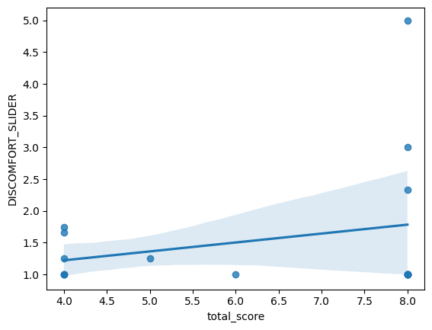

The regression line shows that there is a direct relationship between scores on question 15 and average discomfort level. Therefore, participants with lower scores will report a lower discomfort level.

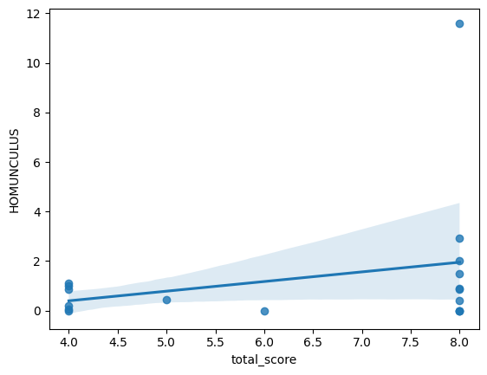

The regression line shows that there is a direct relationship between question-15 scores and average homunculus scores. Therefore, participants with lower scores will report a lower homunculus score (i.e. less pain)

**Analyze and Answer (by Wei-Tse)**

iv. Where are people with their stress levels? Using the data from the Garmin watches as well as the survey data, are stress levels Increased, decreased, no change?

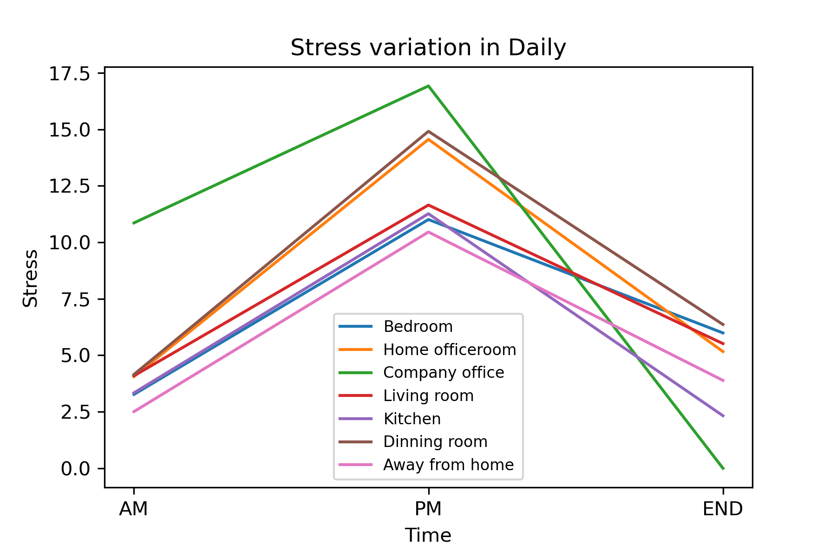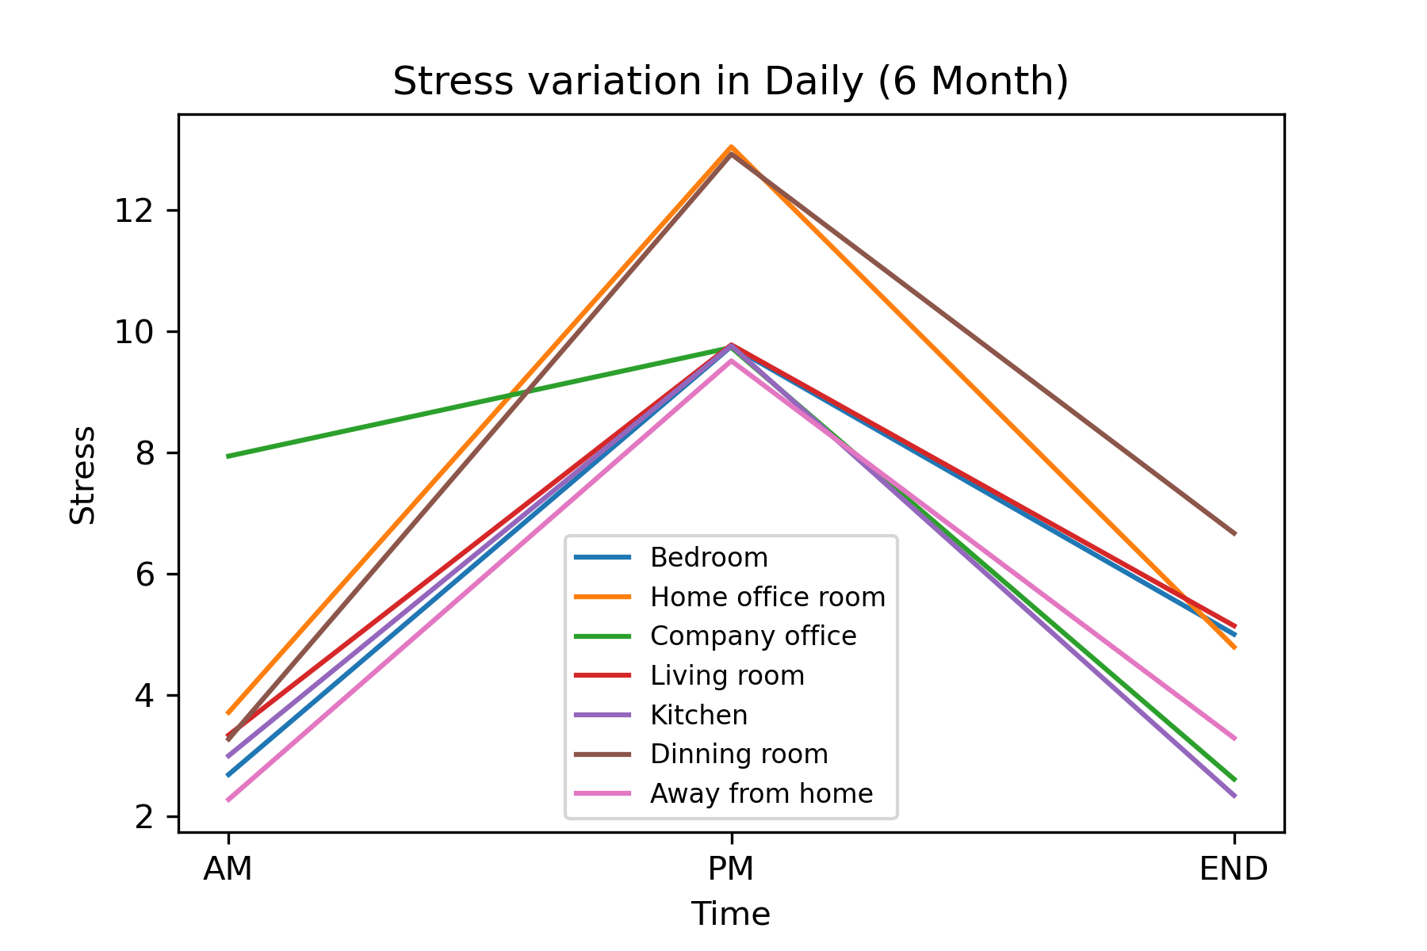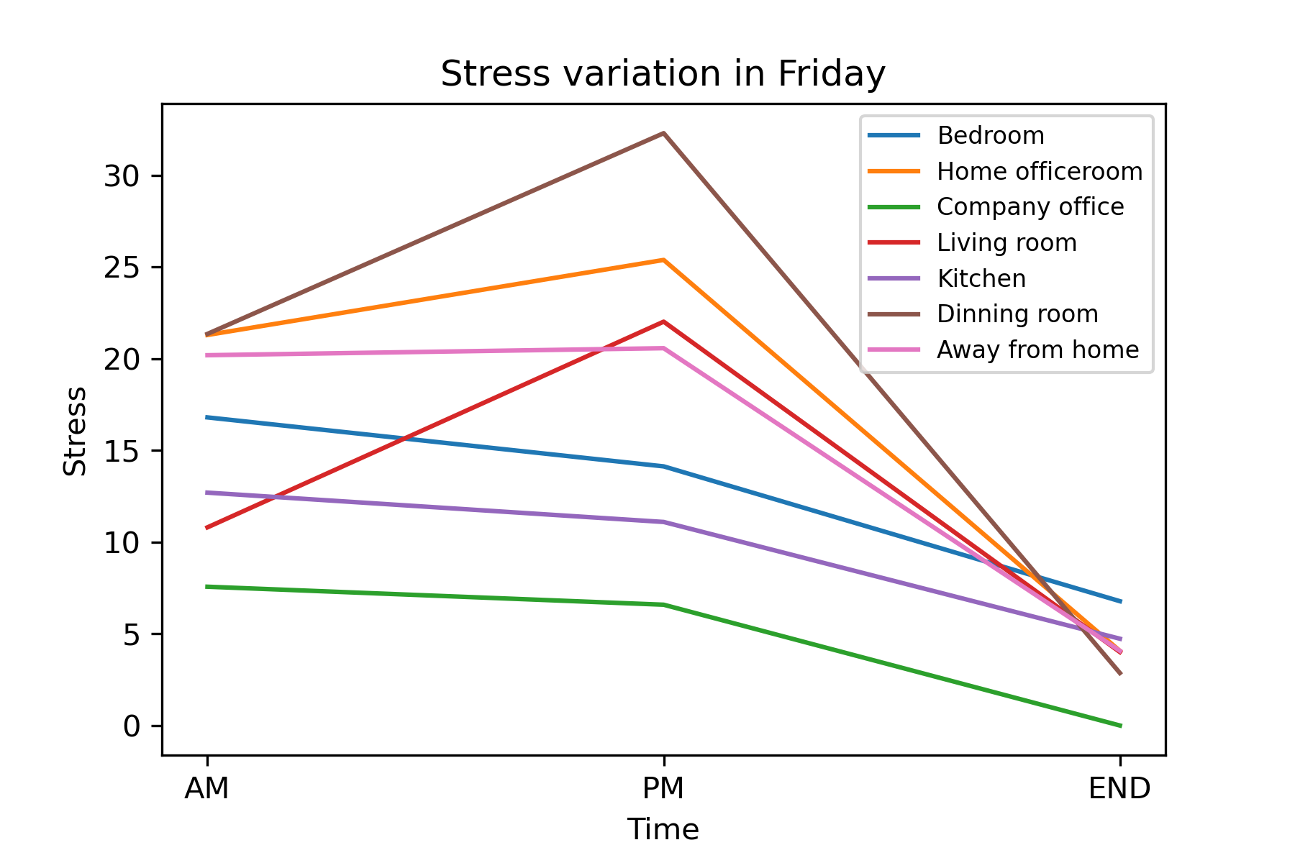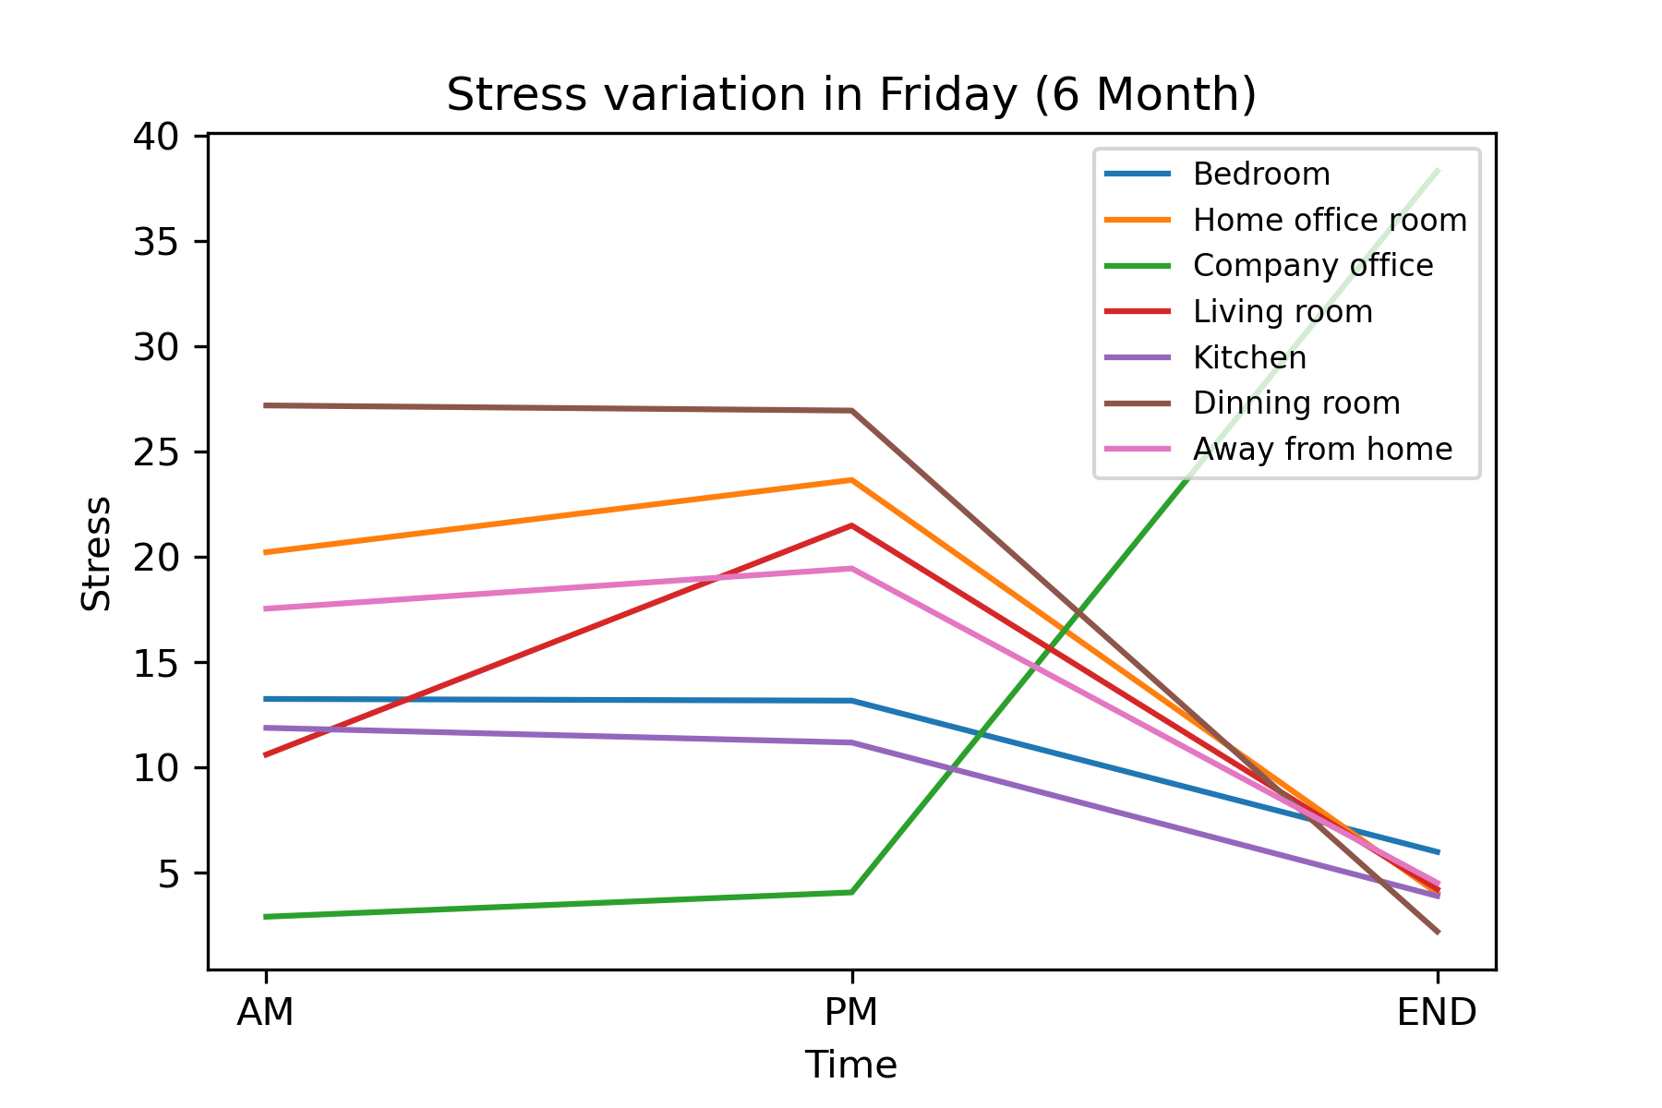

I utilized the “3 month” and “6 month” data in the day(“AM”, “PM”, “END”) including “Daily” and “Friday”, and analyzed them to plot line charts. We can observe the stress level of these locations.

In a day, the stress level will increase at “PM”, and decrease at the “END” of a day.

Comparing daily data in “3 month” and “6 month”, we can find that the stress level at “Home office room” decreases significantly, but the stress level of other locations doesn’t change apparently.

In “6 month data, we can observe that the stress level in Friday data doesn’t change significantly between “AM” and “PM”, and the stress level of all locations decrease at the “END” of the day except the stress level at “Company” office. However, I find that there is only one stress data at “Company office” in the dataset, so the result of the stress level at “Company office” in “6 month” day seems to be uneven.

**Conclusion**

In this project we conducted various analyses to study how remote work has affected employees well being. We conducted analysis using Garmin Data which is real world data. We then found various relationships between Garmin Data and surveys that were answered by the participants for the period of 6 months. In addition to this we also answered hypotheses to find other relationships like age was negatively correlated with financial and material stability, while daily breaks were positively correlated with productivity scores. These findings can help organizations improve employee well-being and productivity. By understanding these relationships, organizations can develop interventions and policies that address the specific needs of their workforce, ultimately leading to a happier and more productive workforce.